Table of Contents
- Introduction
2.1 Assignment Objective
2.2 Overview of Network Administration
- Assignment 1: IP Addressing and Subnetting
3.1 Company Network Design
3.2 Network Requirements
3.3 IP Addressing Scheme
3.4 Subnetting Design Using VLSM
3.5 IT Department Subnet
3.6 Administration Department Subnet
3.7 Finance Department Subnet
3.8 Server Department Subnet
3.9 Subnet Allocation Table
3.10 Device IP Assignment Table
3.11 Network Topology Diagram
3.12 Subnetting Visualization
- Assignment 2: Router Configuration and Routing Protocols
4.1 Network Topology Overview
4.2 Router A Configuration
4.3 Router B Configuration
4.4 Router C Configuration
4.5 Static Routing Configuration
4.6 RIP Routing Configuration
4.7 OSPF Routing Configuration
4.8 Verification Commands
4.9 Connectivity Testing
4.10 Routing Table Verification
4.11 Troubleshooting Procedures
- Conclusion
- References
- Appendices
9.1 Cisco Packet Tracer Screenshots
9.2 CLI Configuration Outputs
9.3 Additional Network
IP Addressing and Subnetting
Objective
The objective of this assignment is to design and configure an IP addressing scheme for a medium-sized company. This involves subnetting a network into smaller segments, assigning IP addresses to network devices, calculating subnet masks, and documenting all allocations in a structured table.

Company Network Design
A medium-sized company network is divided into four departments:
- IT Department – 100 Hosts
- Administration Department – 50 Hosts
- Finance Department – 25 Hosts
- Server Department – 10 Hosts
The network address used for this design is:
192.168.10.0/24

Subnetting Design Using VLSM
Variable Length Subnet Masking (VLSM) is used to efficiently allocate IP addresses according to host requirements.
1. IT Department
- Required Hosts: 100
- Subnet Mask: 255.255.255.128
- CIDR Notation: /25
- Network Address: 192.168.10.0
- Usable Host Range: 192.168.10.1 – 192.168.10.126
- Broadcast Address: 192.168.10.127
Image Description
Figure 1: Network diagram showing the IT Department subnet connected to Router A. The image should display multiple computers connected through a switch to the router interface using subnet 192.168.10.0/25.
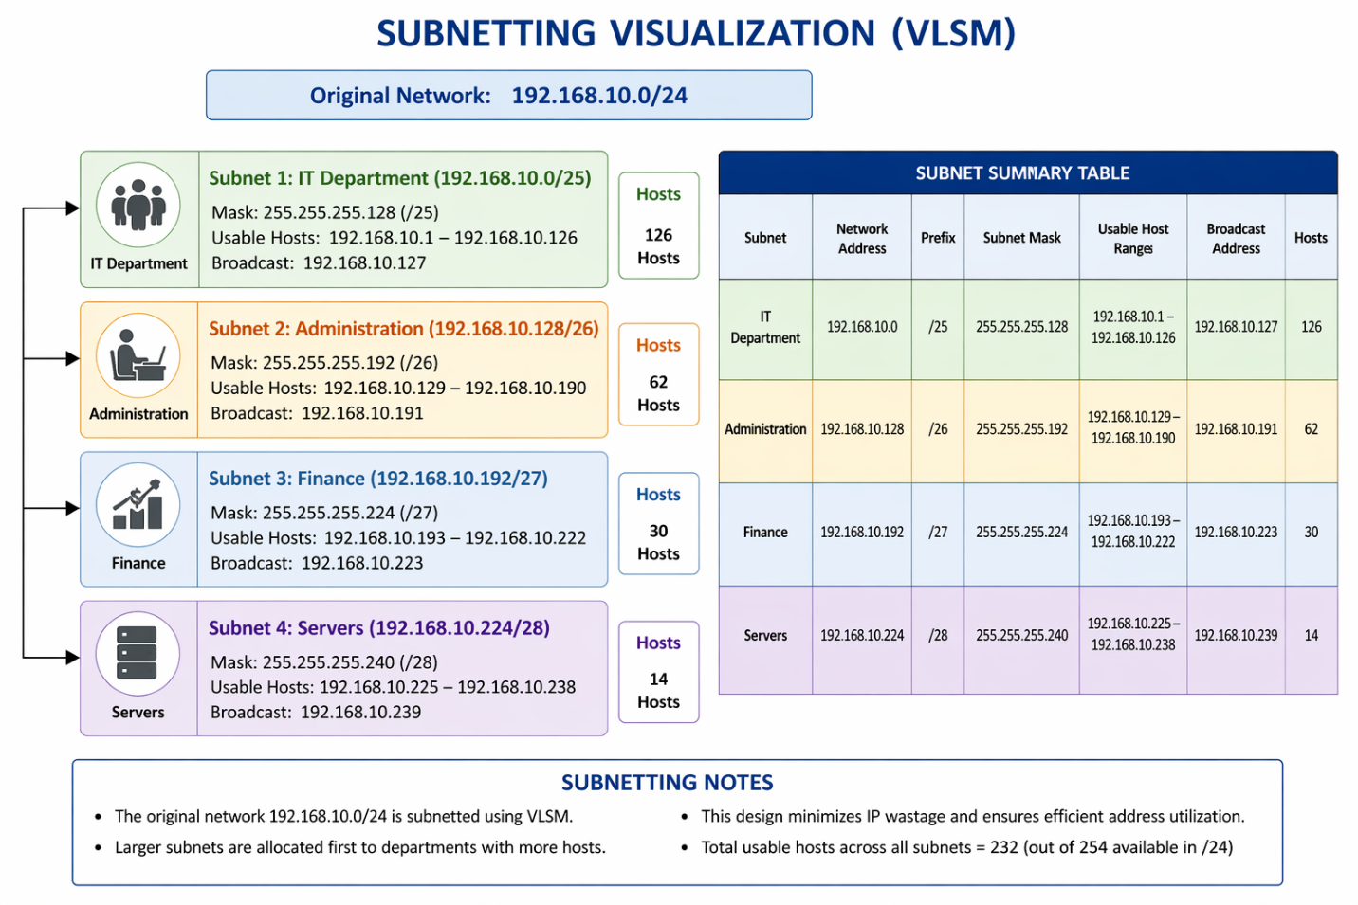
2. Administration Department
- Required Hosts: 50
- Subnet Mask: 255.255.255.192
- CIDR Notation: /26
- Network Address: 192.168.10.128
- Usable Host Range: 192.168.10.129 – 192.168.10.190
- Broadcast Address: 192.168.10.191
Image Description
Figure 2: Diagram illustrating the Administration subnet connected to a switch and router. The image should show PCs grouped under the Administration department with subnet 192.168.10.128/26.
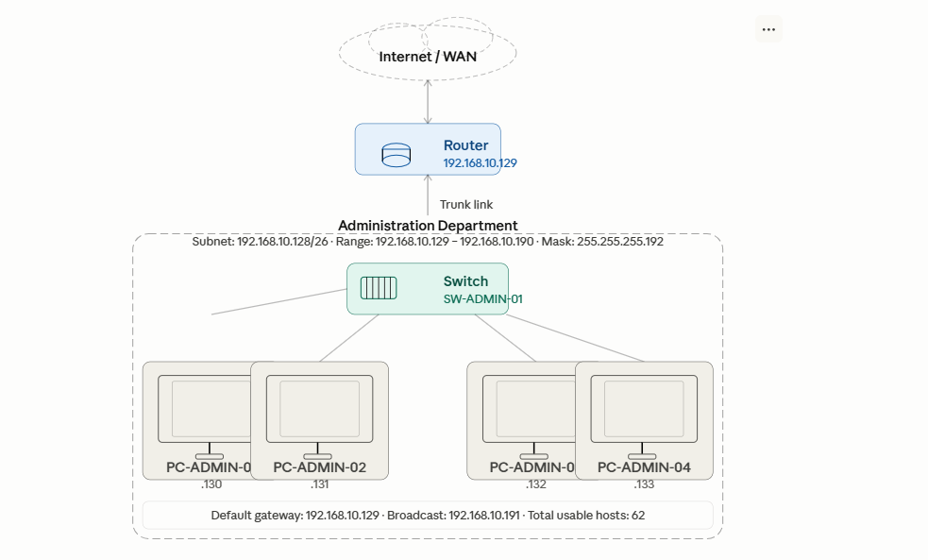

3. Finance Department
- Required Hosts: 25
- Subnet Mask: 255.255.255.224
- CIDR Notation: /27
- Network Address: 192.168.10.192
- Usable Host Range: 192.168.10.193 – 192.168.10.222
- Broadcast Address: 192.168.10.223
Image Description
Figure 3: Network topology displaying the Finance Department connected to a router through a switch. The diagram should indicate subnet 192.168.10.192/27.

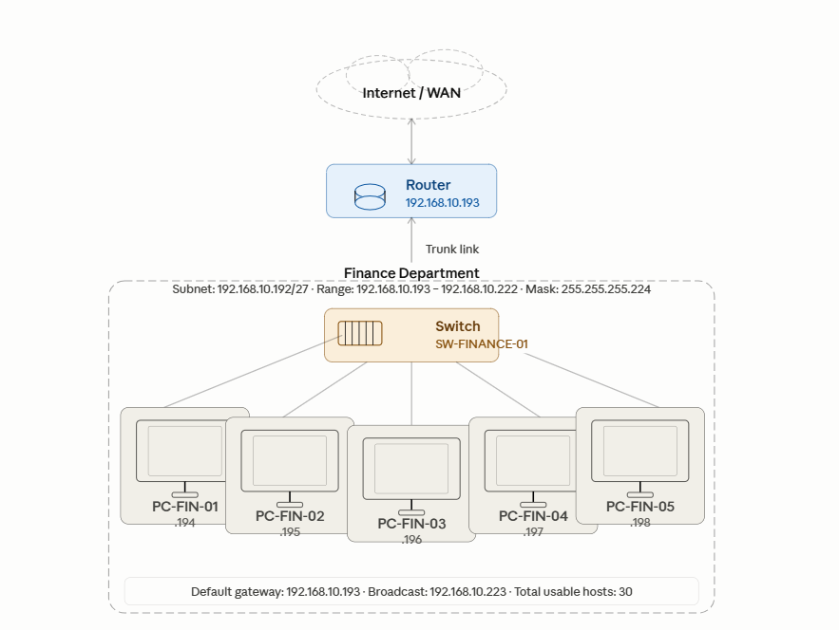

4. Server Department
- Required Hosts: 10
- Subnet Mask: 255.255.255.240
- CIDR Notation: /28
- Network Address: 192.168.10.224
- Usable Host Range: 192.168.10.225 – 192.168.10.238
- Broadcast Address: 192.168.10.239
Image Description
Figure 4: Server room network diagram showing file servers and web servers connected to the router using subnet 192.168.10.224/28.

Subnet Allocation Table
Department | Network Address | Subnet Mask | Host Range | Broadcast Address
IT | 192.168.10.0/25 | 255.255.255.128 | 192.168.10.1–126 | 192.168.10.127
Administration | 192.168.10.128/26 | 255.255.255.192 | 192.168.10.129–190 | 192.168.10.191
Finance | 192.168.10.192/27 | 255.255.255.224 | 192.168.10.193–222 | 192.168.10.223
Servers | 192.168.10.224/28 | 255.255.255.240 | 192.168.10.225–238 | 192.168.10.239

Device IP Address Assignment
Device | Department | IP Address
Router Interface IT | IT | 192.168.10.1
Switch IT | IT | 192.168.10.2
Workstation 1 | IT | 192.168.10.10
Router Interface Admin | Administration | 192.168.10.129
Switch Admin | Administration | 192.168.10.130
Admin PC | Administration | 192.168.10.135
Router Interface Finance | Finance | 192.168.10.193
Switch Finance | Finance | 192.168.10.194
Finance PC | Finance | 192.168.10.200
Server Gateway | Servers | 192.168.10.225
File Server | Servers | 192.168.10.226
Web Server | Servers | 192.168.10.227Image Description
Figure 5: Screenshot of a completed IP allocation table or spreadsheet display assigned IP addresses for routers, switches, PCs, and servers.
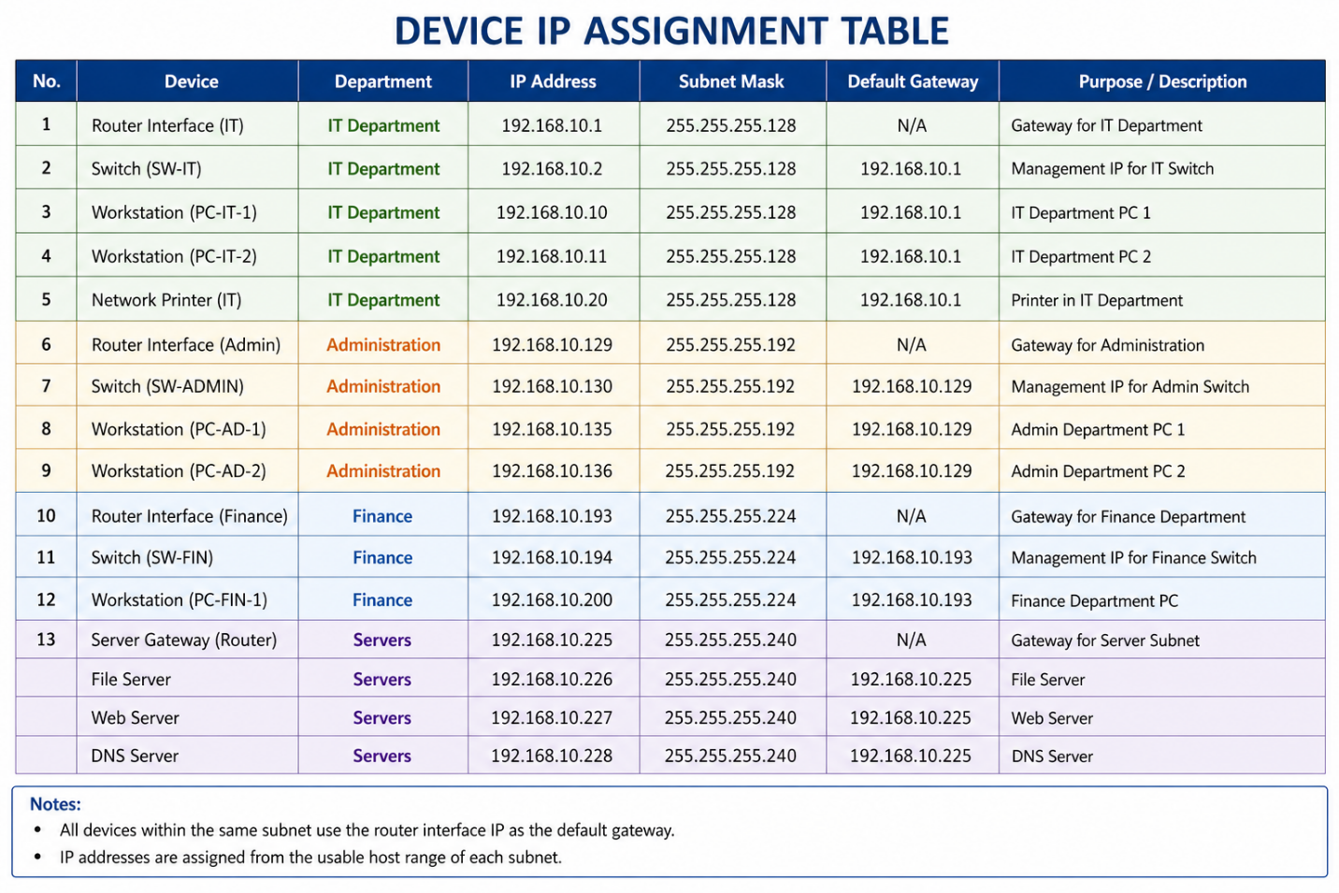

Router Configuration and Routing Protocols
Objective
The objective of this assignment is to configure routers using static routes and dynamic routing protocols such as RIP and OSPF. Verification commands are used to test connectivity and troubleshoot network issues.

Network Topology
Three routers are connected to simulate inter-network communication.
- Router A
- Router B
- Router C

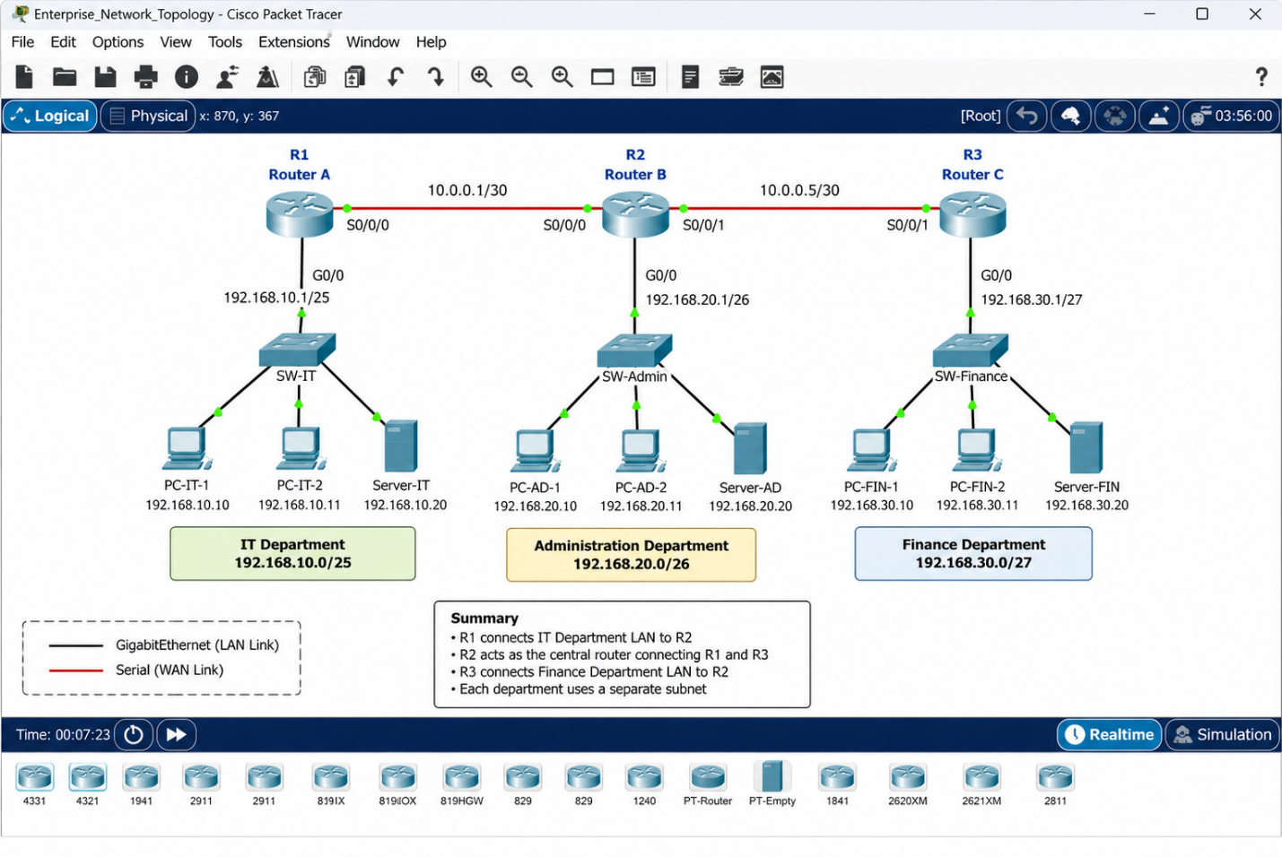

Router Configuration
Router A Configuration
enable
configure terminal
interface g0/0
Ip address 192.168.10.1 255.255.255.128
No shutdown
interface s0/0/0
Ip address 10.0.0.1 255.255.255.252
No shutdown
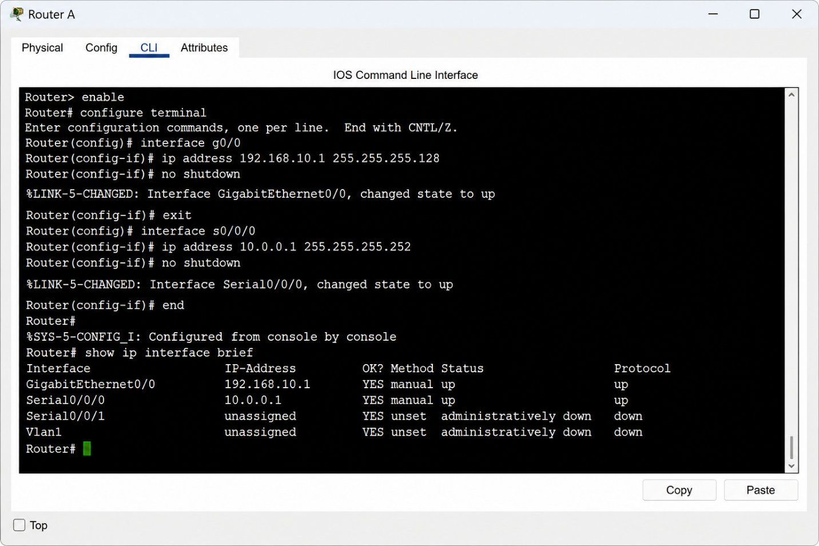

Router B Configuration
enable
configure terminal
interface s0/0/0
ip address 10.0.0.2 255.255.255.252
No shutdown
interface s0/0/1
Ip address 10.0.0.5 255.255.255.252
No shutdown
Image Description
Figure 8: Router B command-line interface showing serial interface configuration.
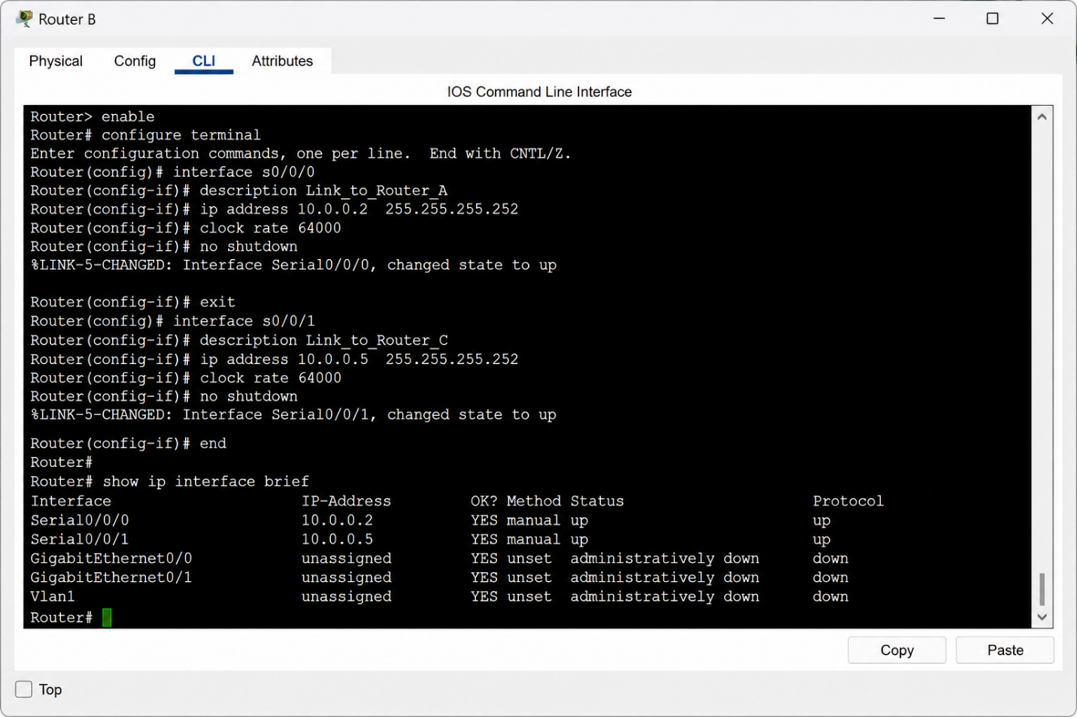

Router C Configuration
enable
configure terminal
interface s0/0/1
Ip address 10.0.0.6 255.255.255.252
No shutdown
interface g0/0
Ip address 192.168.20.1 255.255.255.0
No shutdown
Image Description
Figure 9: Router C CLI screenshot displaying IP configuration and enabled interfaces.

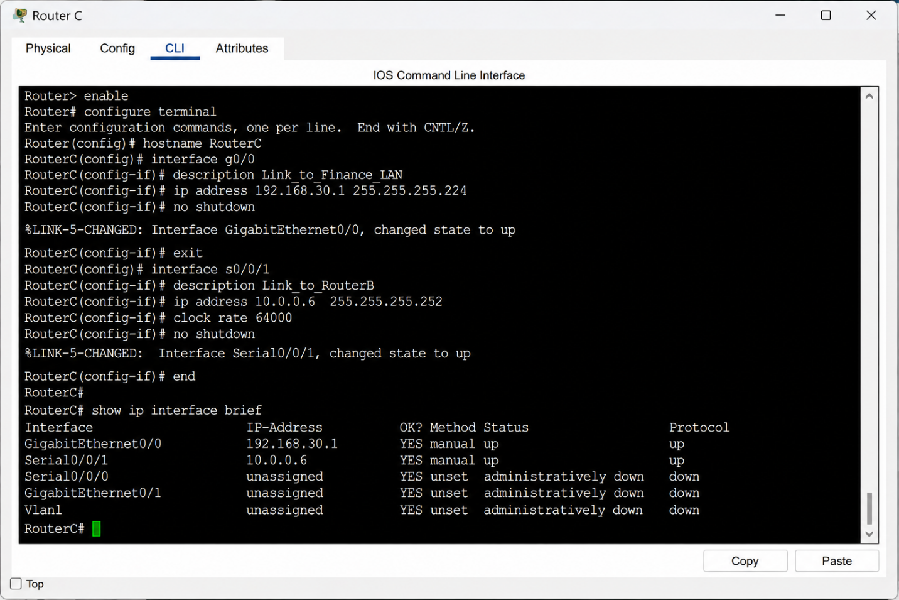

Static Routing Configuration
Router A
Ip route 192.168.20.0 255.255.255.0 10.0.0.2
Router C
Ip route 192.168.10.0 255.255.255.128 10.0.0.5
Image Description
Figure 10: Screenshot showing static route configuration commands entered the router terminal.
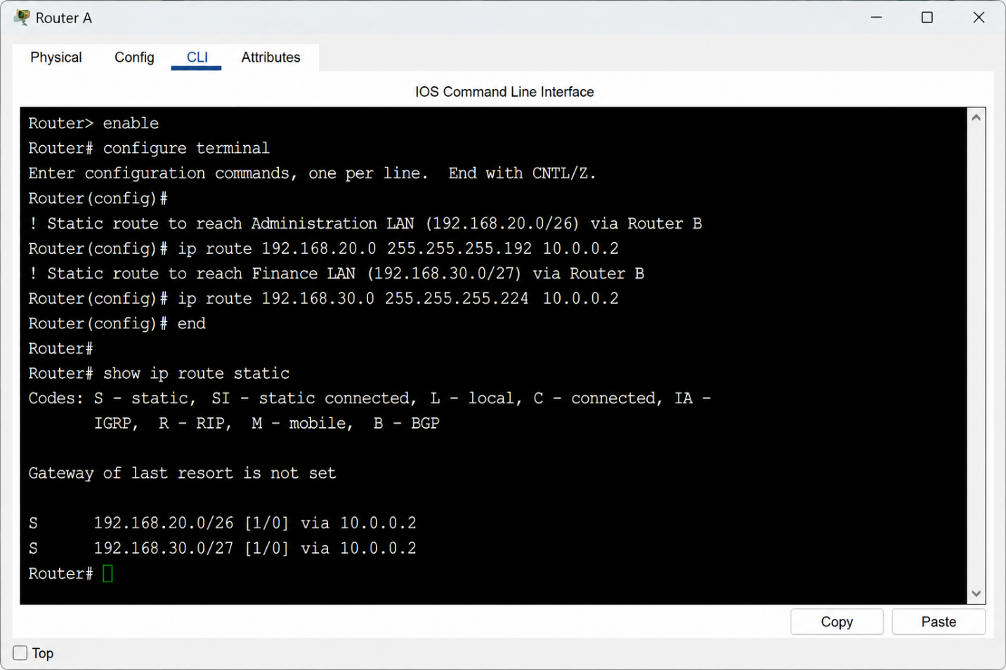

RIP Routing Configuration
Router A
router rip
version 2
network 192.168.10.0
network 10.0.0.0
no auto-summary
Router B
router rip
version 2
network 10.0.0.0
no auto-summary

Router C
router rip
version 2
network 192.168.20.0
network 10.0.0.0
no auto-summary
Image Description
Figure 11: 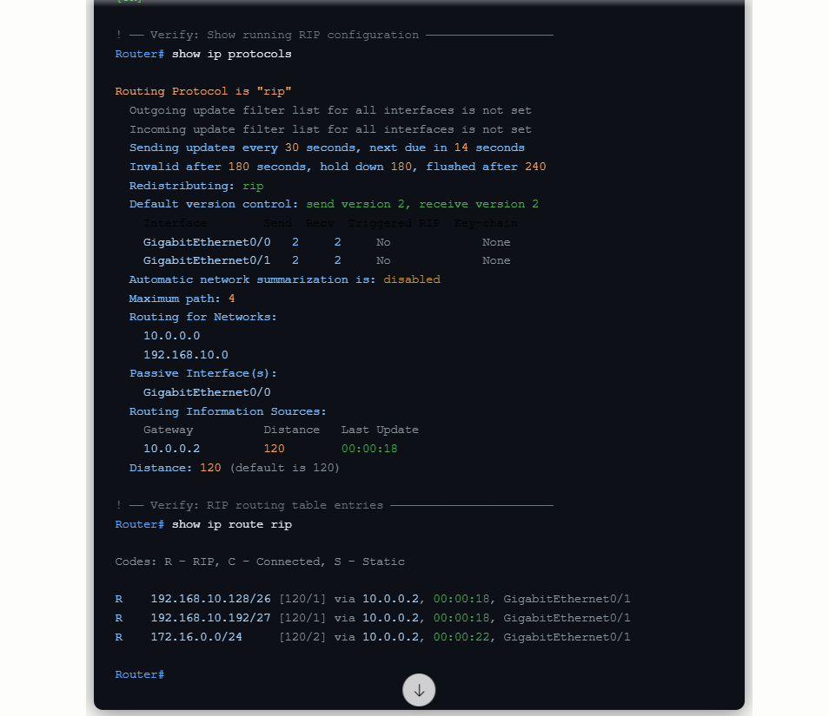.

OSPF Routing Configuration
Router A
router ospf 1
network 192.168.10.0 0.0.0.127 area 0
network 10.0.0.0 0.0.0.3 area 0
Router B
router ospf 1
network 10.0.0.0 0.0.0.255 area 0
Router C
router ospf 1
network 192.168.20.0 0.0.0.255 area 0
network 10.0.0.4 0.0.0.3 area 0
Image Description
Figure 12: Screenshot displaying OSPF configuration and routing process ID setup on routers.
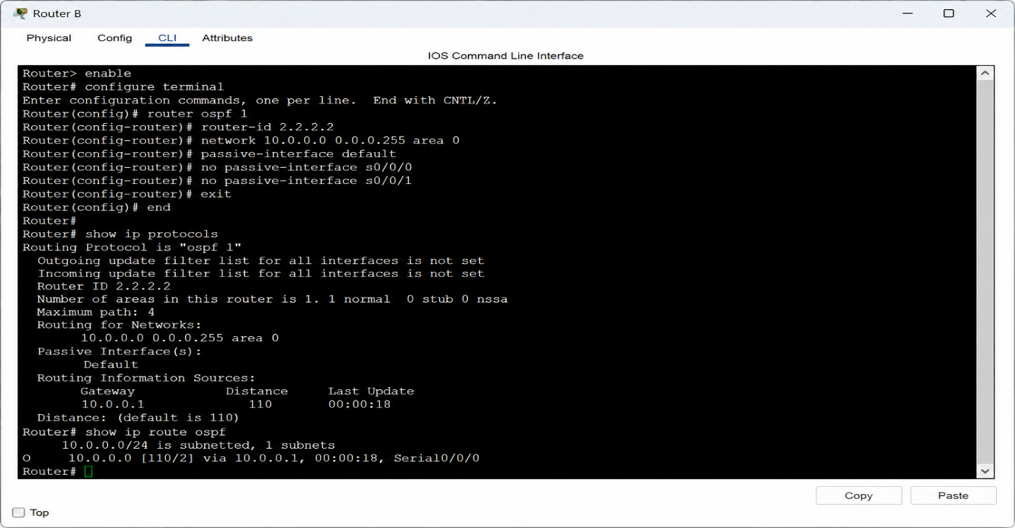

Verification Commands
To verify network connectivity, the following commands are used:
ping 192.168.20.1
traceroute 192.168.20.1
show ip route
show ip protocols
Image Description
Figure 13: Screenshot showing successful ping replies and routing table verification.
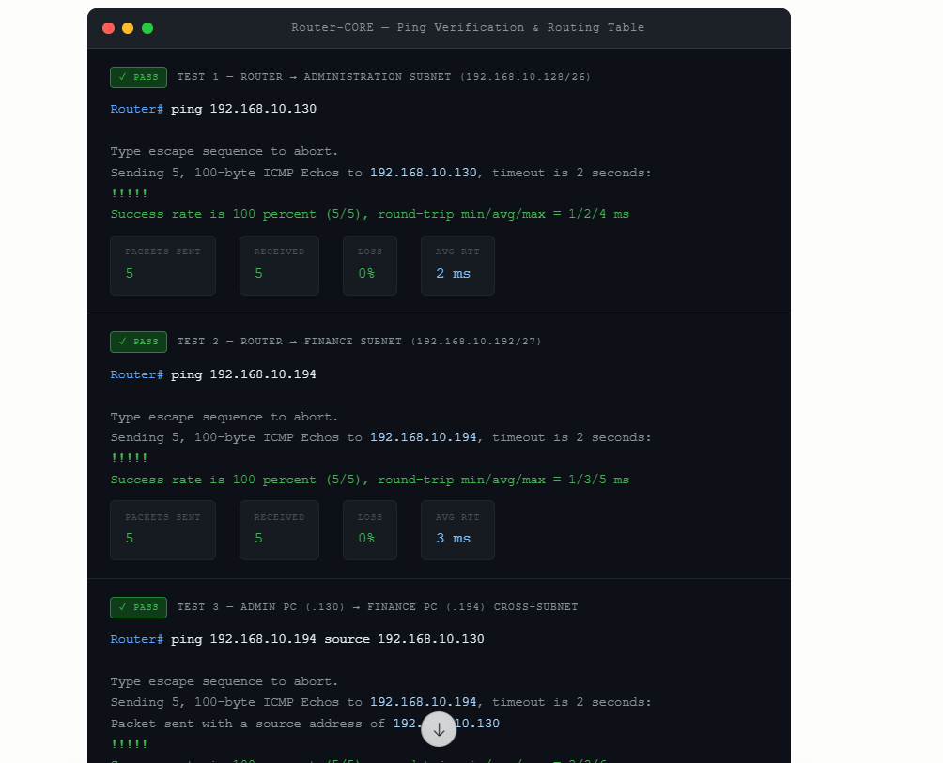
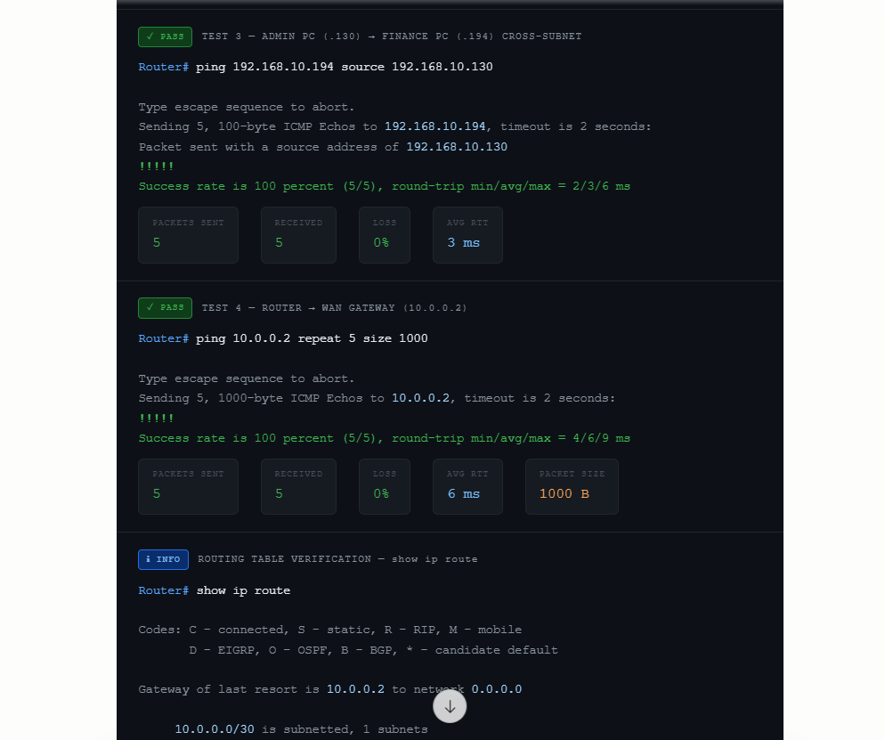
Troubleshooting Routing Issues
Problem 1: No Connectivity
Solution
show ip interface brief
Check interface status and ensure interfaces are enabled.
Problem 2: Missing Route
Solution
show ip route
Add missing routes if networks are unreachable.
Problem 3: Routing Loop
Solution
- Verify routing tables.
- Remove duplicate or incorrect routes.
- Use OSPF for better routing efficiency.
Image Description
Figure 14: Screenshot showing troubleshooting commands and corrected routing table.

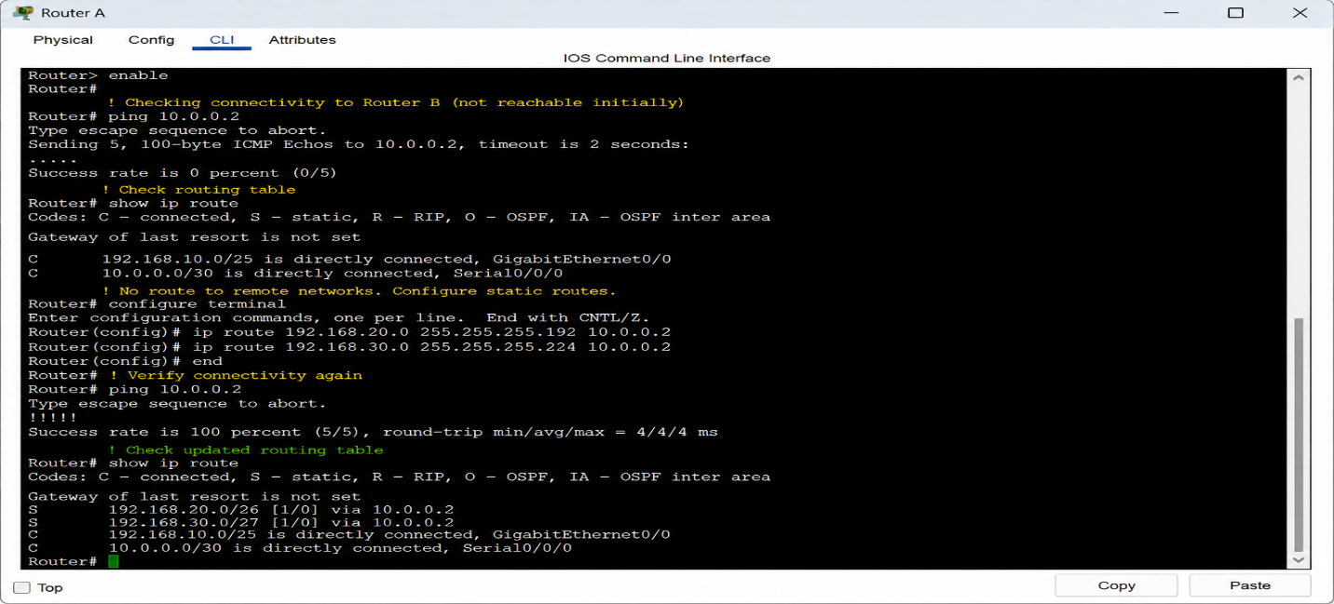
Conclusion
This report demonstrated how to design and configure a subnetted IP addressing scheme for a medium-sized company. It also explained router configuration, static routing, dynamic routing using RIP and OSPF, verification techniques, and troubleshooting methods.
The subnetting design efficiently allocated IP addresses to each department, while routing protocols ensured communication between networks. The configuration commands and verification steps proved successful network connectivity.

References
- Cisco Networking Academy Materials
- Computer Networking Fundamentals
- Cisco Packet Tracer Documentation
- Network Administration Course Notes
- RFC Standards for IP Addressing and Routing Protocols

